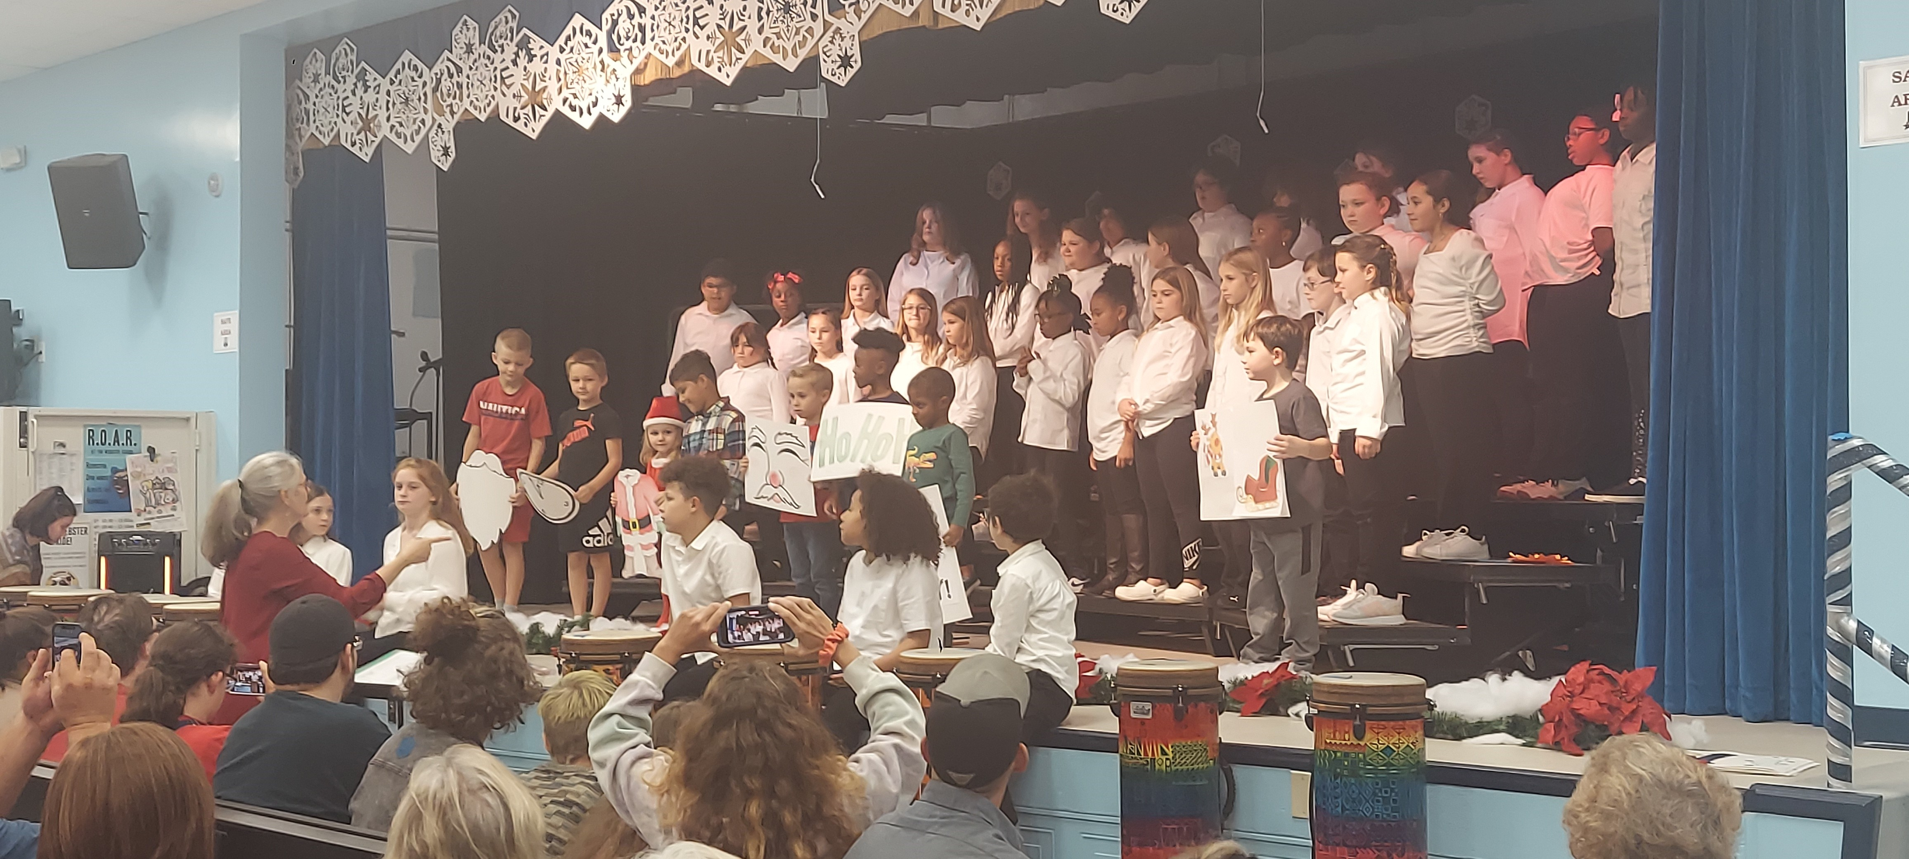  WE CAN Nights 23-24  Webster Elementary Community Access Nights (WE CAN) are usually held on the second Thursday of each month from 5:30 – 7:00 PM.  These evenings are a combination of food and community connection, parent information and student performance. Additionally, the media center, computer labs, and health kiosk are available for community access as needed.  School Leadership  Bethany Groves – Principal  Danielle Coates – Assistant Principal  Shonda Watson – Assistant Principal  Raleigh Burney – Community Partnership School Director  Rob Hall – Instructional Literacy Coach  Darnitah Moultrie – Behavior Interventionist | Who We Are  About Us  We are a Pre-K – 5th grade neighborhood elementary school in St. Augustine, Florida and are part of the St. Johns County School District. We proudly support all students to reach high levels of learning and character to continue toward their life goals of education, employment, and personal success. Our Community Partnership School team works alongside our school faculty to remove all barriers to learning for students and families. These services include support for physical needs, counseling, health care, second language services, after school care and enrichment activities. Core partners include Flagler Health Plus, Flagler College, Children’s Home Society, St. Johns River State College, and the St. Johns County School District.  Webster Elementary School  420 North Orange St. St. Augustine, FL 32084 | Home of the Wolverines  420 North Orange Street  St. Augustine, Florida 32084  904-547-3860  https://webster.stjohns.k12.fl.us  Webster Elementary School  - School – Parent – Student Compact 2023 - 2024
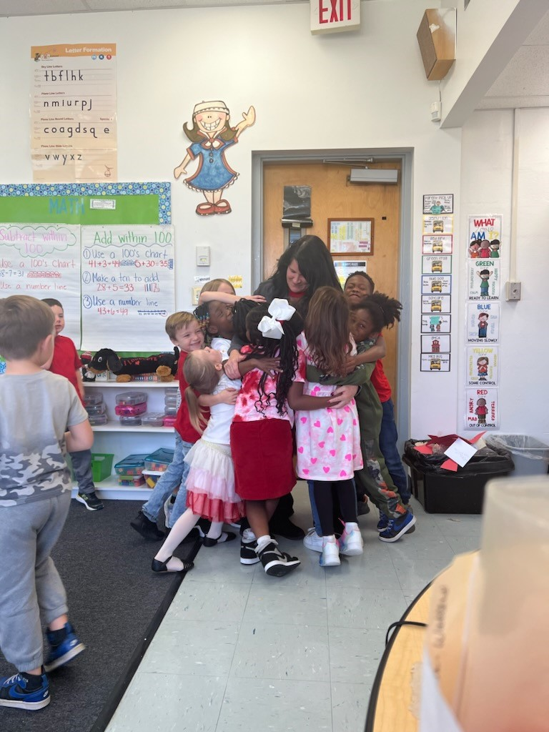  As a school, we will…  Provide parents and community with information regarding curriculum, student progress, school goals, and overall school progress.  Hold conferences and programs with parents in order to develop plans of support for academics and behavior that inform parents of progress and student needs.  Communicate with respect and dignity for everyone at all times.  Provide high quality instruction that leads to academic growth for all students. | As a parent, I will…  Assure my child attends school daily and on time. Excessive tardies and absences will be addressed by the MTSS Team and administration.  Play an active role in my child’s education by communicating with teachers and staff members.  Support the school’s rules and expectations of its students.  Treat all citizens of Webster (faculty, staff, students, and other parents) with respect and dignity.  Follow arrival and dismissal procedures that support the safety of all students.  Attend school functions when available as a means of communication and support between home and school.  When home and school communicate regularly and actively support the efforts of each other, greater student academic success and positive character development result. | 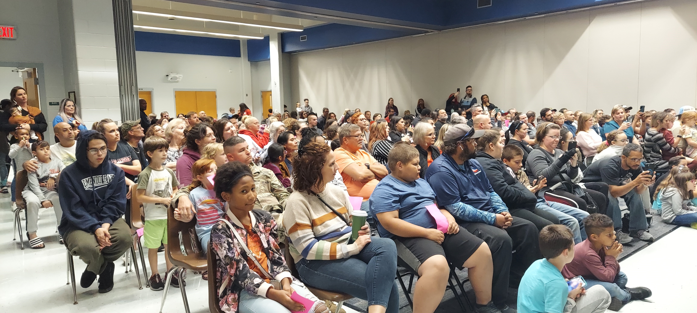  Student Performance and Parent Information Night for a WE CAN Night  As a student, I will...  Attend school daily and be on time.  Show pride in my school by respecting all citizens and follow school-wide expectations.  Come to school ready to learn, always grow and give my best effort.  Complete all assigned work to the best of my ability while using my planner daily.  Have a growth mindset and realize that all things are possible with effort and hard work. 